**Implementation Plan Template for Renewable Energy Generation Business Model**

May 2024



### Note to readers:

This project implementation plan template has been designed by RMI with support from the Global Energy Alliance for People and Planet (GEAPP) as part of a distributed energy resource (DER) toolkit that aims to accelerate DER project development in Nigeria. This is a draft document which has been released to obtain feedback from potential users.

# Introduction

This implementation plan outlines the steps, processes, and recommendations for the timely identification, development and execution of the Renewable Energy Generation Business Model (REG) for areas with large Commercial and Industrial customer concentration from project initiation to operations. This implementation plan is part of the Distributed Energy Resources Toolkit (DER Toolkit) that RMI developed to support Electric Distribution Companies (DisCos) and DER developers in implementing utility-enabled DERs. The toolkit includes several resources and templates that Electric Distribution Companies (DisCos) can reference and modify for use in their own utility-enabled-DER projects.

This document lays out the key steps an Electric Distribution Company (DisCo) would have to take to implement a REG project successfully. Section 2 provides an overview of the main implementation steps, from initiation to execution, including the roles and responsibilities of DisCos and DER project developers (“developer”), as well as the recommended timelines for each step. Lastly, Section 3 discusses the key risks that need to be addressed, along with proposed mitigation strategies.



***Figure 1 — Summary of the Interconnected minigrid business model***

|  |
| --- |
| **This document…** |
| * is for utility leaders who want to use a REG project to improve service and increase their revenues * will help readers understand the steps required to initiate, prepare and execute a REG project * includes advice on defining responsibilities between utilities and DER project developers * prepares you to understand how long it will take to complete each steps, and how you can mitigate common risks along the way * outlines the steps for achieving compliance with all institutional, legal, regulatory and standards requirements, including all necessary approvals, certifications and permits and their typical timeline |

# Implementation Phases and Steps for Projects

There are three main phases in the implementation of a REG project: initiation, preparation, and execution. These steps are led by a team within the DisCo (the project team), and are further described below. If the project team feels that the developer is better suited to lead a particular step, it can delegate that step to the developer, but ultimately, the DisCo is responsible for overseeing the process and should endeavour to lead these steps.

***Table 1 — Summary of the business model implementation process for DisCo-led projects***

| Phase | Description |
| --- | --- |
| Initiation Phase | * The utility will identify potential customers needing reliable power and initiate engagement to gauge interest and business model fit. |
| Preparation Phase | * The utility will conduct technical assessment, design a DER solution, select a developer, and finalize the DER solution design alongside the selected developer. |
| Execution Phase | * The utility, the developer and the customer will sign a final contract. The system will be constructed and the distribution network upgrades will be implemented. Services to the customer will be initiated based on the terms of the agreement. |

## Overview of Implementation Steps

## Initiation

|  |  |  |  |  |
| --- | --- | --- | --- | --- |
| **Phase I:** | **Initiation** |  | **Duration:** | **1.5 months** |
| **Key steps for developers and DisCos** | | | | |
|  | | | | |
| **DER Toolkit resources** | | | | |
| * *Data collection methodology for identification and de-risking DERs* | | | | |

**Step 1 — REG cluster shortlisting**

The first step in implementing a REG project is to identify the right area for the project. The project team should analyze commercial data of feeders served by the DisCo and shortlist feeders that have the right characteristics. These characteristics include high usage of self-generation, high demand for electricity, and a high concentration of maximum demand (MD) customers. Shortlisted feeders for REG should have a minimum load of 200MWh, with at least 30% of energy consumed by MD customers[1]. The exact data required in this process, their sources and recommendations for improving the availability of this data can be found in the ***Data collection methodology for identification and de-risking DERs*** included in the Toolkit.

**Step 2 — REG cluster selection and site visits**

Once a few feeders are shortlisted, the next step is to select a REG cluster for the project. The project team should rank feeders based on the Maximum Demand (MD) customer concentration, which is the proportion of energy consumed by MD customers on a feeder compared to the total energy consumed. The team should then align with the management team and broader stakeholders within the DisCo to review the ranked list and decide on which feeder is best suited for a REG solution based on the company's strategy. Additionally, the project team should visit the area, discuss the project with the local team, understand the challenges with power supply in the area, and further demarcate the REG Cluster based on the MD Customer concentration. For example, if an area has three 11 kV feeders and one of these feeders has a very low concentration of potential premium customers, the DisCo could choose to implement REG on just two of the 11 kV feeders rather than implementing a solution for the whole area.

## Preparation

|  |  |  |  |  |
| --- | --- | --- | --- | --- |
| **Phase II:** | **Preparation** |  | **Duration:** | **6 months** |
| **Key steps for developers and DisCos** | | | | |
|  | | | | |
| **DER Toolkit resources** | | | | |
| * *Distribution Network Assessment Template* * *REG Premium Customer Information Brief* * *REG Premium Customer Letter of Intent Template* * *Homer resources for DER system design* * *REG Financial Model Template* * *Benchmark costs document* * *RFQ template and RFQ evaluation template* * *REG RFP template and RFP evaluation template* | | | | |

**Step 3 — Distribution network assessment**

Once a final REG cluster is selected, the project team should conduct a study to assess the distribution network to understand the issues affecting reliability on the network, catalogue existing infrastructure on the network, understand how customers are arranged across the network and determine the most cost-effective way to upgrade the distribution network to improve reliability to customers in the REG cluster[2]. This study should produce an updated network diagram for the cluster, the network upgrades needed in the cluster, their associated costs and approved vendors that can carry out the upgrades and the number of hours of bulk grid electricity supply that can be guaranteed to the REG cluster if these upgrades are implemented. The project team can use the ***Distribution Network Assessment Template*** to guide this process.

**Step 4 — Customer Engagement**

After completing the assessment of the distribution network, the project team should

confirm prospective premium customers’ interest in the REG solution. The project team should engage all existing MD customers, and large commercial and industrial customers defected from the grid within the cluster to determine if they are interested in becoming REG premium customers. If interested, customers should sign a non-binding letter of interest. To engage these customers, the project team can utilize the ***REG Premium Customer Information Brief*** and modify the ***REG Premium Customer Letter of Intent Template.*** The project team should also engage select non-MD customers to understand their current energy expenditure and their major energy concerns.

Once the above steps are completed, the project team should conduct a detailed customer enumeration exercise to determine the exact number of unique customers in the proposed REG cluster and collect key information on each customer. The exact data required in this process, their sources and recommendations for improving the availability of this data can be found in the ***Data collection methodology for identification and de-risking DERs*** included in the Toolkit.

**Step 5 — DER System Design**

The next step in the process is to design an optimal DER solution for the REG cluster. The output of this process is an initial DER system solution that includes the system technical design and an initial REG tariff for the project. Below are the detailed steps involved in this process[3].

1. **Load Profile Assessment** – To understand the load profile for the REG clusters for the design of the DER solution, historical load data from the feeders at the substation should be gathered. The project team should also install power data logger to measure the power consumption of a selection of the potential REG premium customers. Alternatively, if these customers have meters that store power consumption data that can be accessed by the project team or an “AMI” meter, the historical energy consumption data can be extracted from it. All this data should be combined and used to develop a load profile for the REG cluster which will be used for DER sizing and dispatch simulation.
2. **Technical Modelling** – The project team should design an optimal least-cost, high reliability DER solution for the REG cluster. A hybrid DER system consisting of solar, battery and backup diesel or gas generators will likely be the most cost-effective solution. Tools like Homer Pro[4] and System Advisor Model[5] can be used to design the system. The ***Homer resources for DER system design*** included in the DER Toolkit provides introductory resources such as a training video and a user manual to help users get started with the software.
3. **REG Interconnection Study** – The project team will conduct additional studies to determine the feeder hosting capacity and understand the DER system interconnection requirements. Additionally, the study will determine the appropriate measures to reduce collection losses and allow for the differentiation and isolation of premium customers from non-premium customers. The cost of implementing these solutions will also be determined.
4. **Economic and Financial Modelling** – To determine a viable initial REG tariff, the project team will run an economic model that factors in projected capital costs and operational expenses and determines the economic viability of the designed solution for customers in the REG cluster, the developer and the DisCo. The project team can use the ***REG Financial Model Template***, and the ***Benchmark costs document*** for modelling.

**Step 6 — Developer Selection**

The next step is to procure a developer to execute the REG project[6]. The detailed steps involved in attracting and selecting the most qualified developer to implement the project are[7]:

1. **Request for Qualification (RFQ) –** The project team will issue an RFQ to identify a pool of pre-qualified developers who will be eligible to receive a more detailed Request for Proposals (RFP). The RFQ will assess developers on their project implementation track record, their commercial history, their financial capabilities, and their reputation/integrity among other qualification factors. The team can use the ***RFQ template*** and evaluate developers using the ***RFQ evaluation template*** included in the toolkit.
2. **Site Visits –** The project team should conduct site visits to the area with pre-qualified developers to improve developer’s understanding of the REG cluster.
3. **Request for Proposals (RFP)–** The project team will issue an RFP to the pre-qualified developers that includes all the relevant data on the REG cluster, and select the winning developer to implement the REG. The team can use the ***RFP template*** and evaluate proposals using the ***RFP evaluation template*** included in the toolkit.

## Execution

|  |  |  |  |  |
| --- | --- | --- | --- | --- |
| **Phase III:** | **Execution** |  | **Duration:** | **10 months+** |
| **Key steps for developers and DisCos** | | | | |
|  | | | | |
|  | | | | |
| **DER Toolkit resources** | | | | |
| * *REG Model Term Sheet* * *REG Agreement Template* * *REG Connection Agreement* * *Project Execution Workplan* * *REG DisCo Workplan Template* | | | | |

**Step 7 — Power Supply Contract Negotiations and Signing**

There are two key contracts/agreements that govern the stakeholder relationships for a REG project: the embedded generation agreement between DisCo and the developer, and the power purchase agreement (PPA) between the DisCo and the premium customers. The detailed steps involved in negotiating and signing these agreements are:

1. **Embedded generation agreement negotiation** - The project team will negotiate and agree upon key terms of an embedded generation agreement with the developer. Important terms to align on include the framework for determining the final system tariff schedule and conditions for tariff review; REG availability, reliability and underperformance clauses; customer service processes, dispute resolution mechanisms and allocation of shortfall risk. Parties can use the ***REG Model Term Sheet*** when negotiating before modifying the ***REG Agreement Template*** and ***REG Connection Agreement***
2. **Premium customer PPAs negotiation** – After negotiating its agreement with the developer, the project team would negotiate power purchase agreement (PPAs), including preliminary tariffs with premium customers. The project team can modify the ***REG Premium Customer PPA Template*** provided in the Toolkit.
3. **System design update** – The project team, alongside the developer, will revisit the initial system design and financial model and make any needed modifications.
4. **Embedded generation agreement finalization and signing** – The final embedded generation agreement, including the final system design, final tariff for electricity sales from developer to DisCo and payment schedules, will be agreed on and signed.
5. **Premium customer PPAs finalization and signing** – The project team will finalize the power purchase agreement with premium customers.

**Step 8 — Establishment of Independent Collections Account**

The independent collections account (ICA) which separates customer payments from the REG cluster from the DisCo’s broader collections, is an important part of the REG business model. *The ICA* is in line with the *Guidelines for Secondary Escrow Account Management for Bilateral Transactions by Electricity Distribution Licensees (2023*). The steps needed to establish the ICA include:

1. **Develop internal operational processes for the ICA -** Implementing the ICA will require some adjustments to DisCo’s existing collections processes. The DisCo team should engage their current payment partners, re-configure their current commercial systems to track REG customer payments and set up the ICA account.
2. **Negotiate and sign an agreement on the ICA with the developer -** The DisCo and developer will negotiate and agree upon terms of the ICA, including ICA management, settlement periods, dispute resolution and so on, with the developer.

**Step 9 — Regulatory Approval**

T*o* get regulatory approval, the project team will coordinate with the selected developer to submit applications for the Embedded Generation License and approval for the ICA to Nigerian Electricity Regulation Commission (NERC) together with supporting documentation as described in the NERC Embedded Generation Regulation (2012).[8] Appendix A contains a summary of the process to obtain the key licenses and permits for the implementation of a REG project.

**Step 10 — System Construction and Implementation of Distribution Network Upgrades**

The project team will work alongside the project developer to source financing and procure DER components including generation equipment, distribution network equipment needed for upgrades and meters needed in the cluster[9]. The project team will oversee the construction of the DER system in compliance with NEMSA standards and other best practices. The ***Project Execution Workplan*** template can be modified and used to track and manage the developer’s progress while the ***REG DisCo Workplan Template*** can be modified to track the DisCo’s progress in the project’s execution phase.

**Step 11** — **Interconnection, Testing and Commissioning**

Effective interconnection between the DER system and the main grid is a crucial step in project construction. It is important for the DisCo's technical team and the developer to work closely to ensure successful interconnection based on the agreed-upon system designs and standards. To ensure smooth operations, key issues such as retrofitting or installing transformers, poles, distribution cables, and meters, as well as implementing appropriate control, switching, and protection systems between the grid and DER system, must be addressed effectively and tested before commissioning.

After completing all the installation work, the entire system needs to undergo final testing and commissioning. The commissioning process involves testing the different modes of operation of the REG. It also includes training and handover from the technical installing teams or EPC to the developer’s operations team and signoff and acceptance by the DisCo. Finally, the developer has to obtain final certification from the Nigerian Electricity Management Service Agency (NEMSA)[10].

**Step 12 — Operations**

The project team will work with the project developer to ensure the project runs smoothly and the terms of all agreements are fulfilled. The DisCo will maintain the distribution network, carry out billing and collections for customers, ensure proper functioning of the ICA and provide the cluster with electricity per its obligations. DisCos will be held accountable if they fail to meet their obligations and pay penalties for underperformance which could cancel out the gains they receive from this project.

## Roles and Responsibilities for Implementation Steps

During project implementation, DisCos and developers have crucial roles. Table 2 outlines each party's key responsibilities, while Figure 3 displays the process flowchart.

***Table 2 - DisCo and Developer Roles and Responsibilities for implementing a REG project.***

|  |  |  |
| --- | --- | --- |
|  | DisCo – Led Model | |
| Steps | DisCo | Developer |
| Step 1 — REG cluster shortlisting | * Analyze DisCo data to shortlist promising customer clusters | * No role |
| Step 2 — REG cluster selection | * Align with DisCo management * Prioritize REG cluster shortlist * Conduct “windshield” area visit * Select REG cluster | * No role |
| Step 3 — Distribution network assessment | * Conduct assessment of distribution network * Identify network upgrade requirements, associated costs and approved vendors to implement upgrades * Determine number of available hours the DisCo can commit to providing the REG cluster from the bulk grid with the network upgrades * Update feeder network diagram | * No role |
| Step 4 — Customer engagement | * Engage potential premium customers * Sign letter of interest with premium customers * Engage non-premium customers * Perform customer enumeration | * No role |
| Step 5 — DER system design | * Develop load profile for REG cluster * Conduct technical modeling * Conduct REG interconnection study * Perform economic and financial modelling | * No role |
| Step 6 — Developer selection | * Issue RFQ * Assess RFQ submissions * Issue RFP * Coordinate site visit with interested developers * Assess proposals/ bids | * Review and submit response to RFQ. * Review and submit response to RFP * Visit customer site |
| Step 7 — Power supply contract negotiations and signing | * Negotiate embedded generation agreement with developer * Negotiate PPAs with premium customers * Update DER system design * Finalize and sign embedded generation agreement * Finalize and sign PPAs with premium customer | * Negotiate embedded generation agreement with developer * Support PPA negotiations with premium customers and DisCos * Update DER system design * Finalize and sign embedded generation agreement |
| Step 8 — Establishment of independent collections | * Develop internal operational processes for the ICA * Negotiate and sign an agreement on the ICA with the developer | * Negotiate and sign an agreement on the ICA with the DisCo |
| Step 9 — Regulatory approval | * Support additional studies needed for regulators’ approval * Review relevant documents for regulatory approval to ensure quality and compliance * Apply for the approval of the ICA | * Conduct additional studies needed for regulators’ approval * Apply for Embedded Generation license * Support application of the approval of the ICA |
| Step 10 — System construction and implementation of distribution network upgrades | * Implement distribution network upgrades * Oversee construction of system | * Construct system * Finance distribution network upgrades |
| Step 11 — Interconnection, testing and commissioning | * Implement interconnection systems * Test and ensure system complies with technical standards and connection agreements * Commission system | * Implement interconnection systems * Test and ensure system complies with technical standards and connection agreements * Commission system |
| Step 12 — Operations | * Maintain distribution network * Sell electricity to the cluster * Carry out billing and collections in the cluster * Ensure proper functioning of the ICA | * Operate and maintain DER system assets * Ensure adequate service to the customer * Oversee proper functioning of the ICA |

## Expected Timeline

Efficient and timely implementation of the project is of utmost importance as it can significantly impact customer engagement and satisfaction. The project timeline provides a detailed overview of the expected duration for each step involved in the project, from initiation to execution.

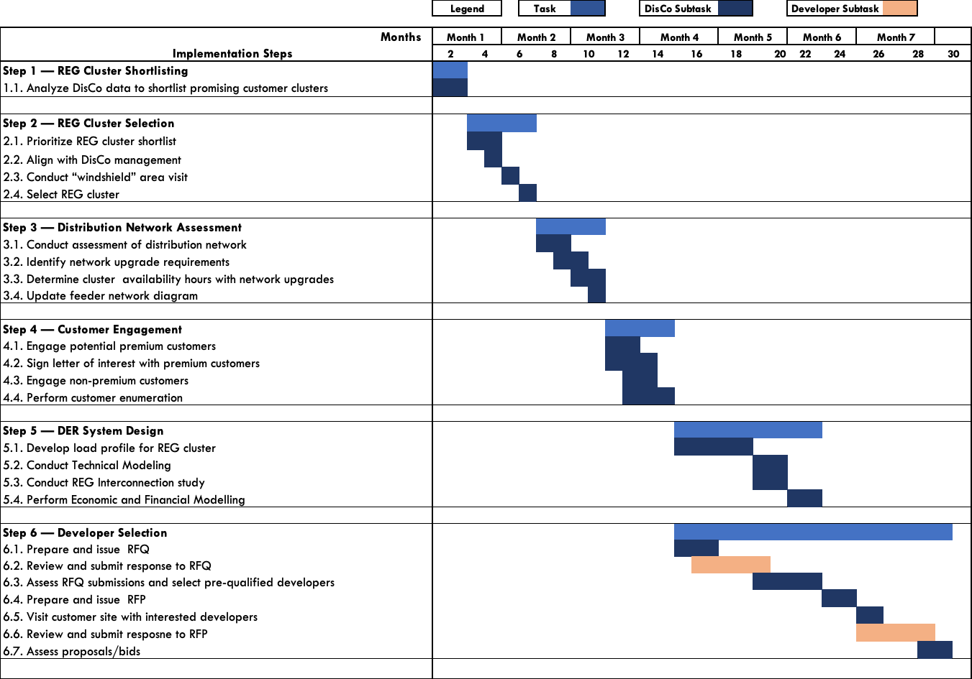

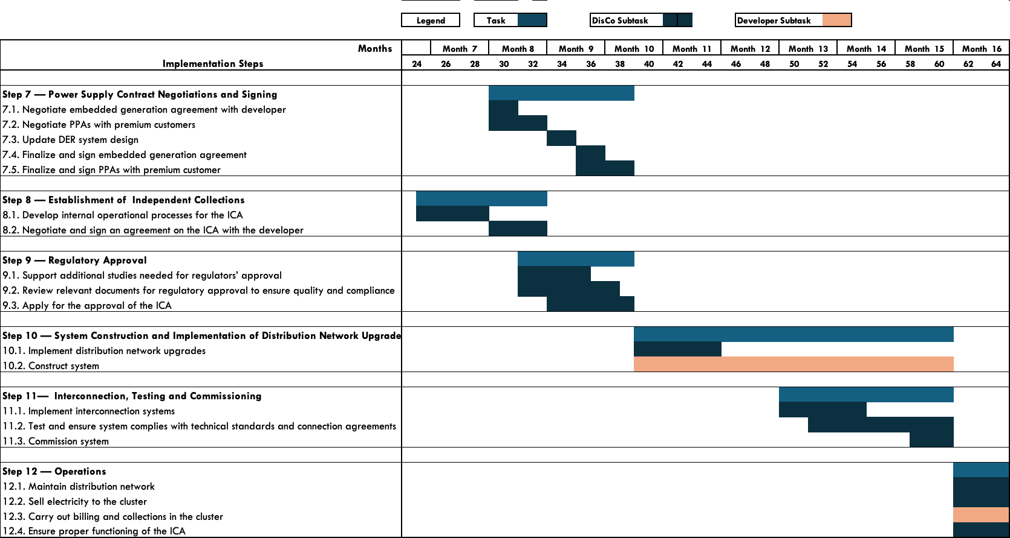

***Table 2 Expected Timeline***

## Implementation Risks and Mitigation Strategies

It is important to identify potential risks that could inhibit the successful and timely completion of a REG project and develop strategies to lessen the negative impact of these risks. Below is a list of the principal external risks identified as having a combination of a reasonable likelihood of occurrence and significant negative impact on the implementation of a REG project.

***Table 3: Implementation risks and mitigation strategies***

|  |  |  |
| --- | --- | --- |
| Risks | Description | Mitigation |
| Project initiation | | |
| Data Inadequacy | Risk that DisCo does not have enough data to shortlist the right customers | The project team should collect as much data as possible that exists within the DisCo and validate the data through engagements with local teams and customers. Data can be extrapolated for customers with similar features. |
| Project preparation | | |
| DisCo stakeholder skepticism | Risk exists that DisCo management and other stakeholders may not fully recognize the value of the REG project or may consider clusters too valuable to let go for a REG project. | The project team should emphasize the needs of potential REG clusters, the risk of grid defection due to inadequate supply, and the opportunity for higher revenues by leveraging global success stories and proof-points of the model. |
| Customer skepticism | Risk that project deployment is hindered due to high level of risk aversion around power supply of premium C&I customer | The project team should engage extensively with premium customers in designing the DER systems to improve their power reliability and reduce their cost. The project team should manage customer relationships effectively, proactively addressing customer concerns as they arise. The selected developer should effectively communicate their track record of deploying similar systems to commercial and industrial customers across various geographies. |
| Lack of capacity to effectively design the DER system | Risk that the DisCo lacks the capacity to design optimal DER systems | The project team can hire a technical partner as a contractor with expertise to design the DER systems using state of art tools. |
| Subpar bids & proposals received during the RFQ & RFP stages | Risk that during the RFQ & RFP stage, the bids from interested developers do not meet the standards required by the DisCos | The DisCo should ensure that a long list of developers with the right capacity and proven track record receive the RFQ and RFP. The team should ensure a diligent evaluation against a robust criteria using the RFP and RFQ evaluation templates |
| Tension between parties | Risk that on one or more of the parties: Customers, Developer and DisCo are uncomfortable with terms of the Power Purchase Agreements. | The project team should manage customer and developer relationships effectively, proactively addressing customer and developer concerns as they arise. The DisCo and developer should be flexible in making changes to the project and agreement structure in the spirit of ensuring a win-win-win for all parties. The developer should support the DisCo in negotiating with premium and non-premium customers based on proven experience of executing projects with higher tariffs. |
| Project execution | | |
| Schedule risk | Risk that project execution takes too long due to:   * Long project preparation timeline * Procurement and logistics during construction * Developer capacity | The project team should work with a highly qualified developer to ensure rapid implementation and help problem-solve any issues that creep up. Additionally, the team should procure long lead time items early in the process and make every effort to adhere to the timelines outlined in this implementation plan. To manage project construction, the team should use the project execution workplan. |
| Speed of regulatory approval | Risk that there are delays in receiving approval from the regulator for the project | Developers who have a track record and experience receiving approvals from the regulator should be selected. The project team and the developer should initiate the regulatory approval process early and leverage on existing relationships with the regulatory agencies. |
| Misalignment on equipment choice | Risk that there is a misalignment between developer and DisCo on choice of equipment. | The project team should be fully aligned with the developer on distribution network upgrades and share an approved list of vendors to implement the upgrades. The project team and the DisCo should agree on an interconnection roles and responsibilities prior to signing the embedded generation agreement. |
| Poor/substandard project execution by DER developer | Risk that the developer does not construct project to the required standards | It is essential that the DisCo closely monitors the developer's progress throughout the project. The project team should develop a joint project execution workplan with the developer and track progress against it. The project team should also visit the site on a monthly or bi-monthly basis to inspect progress and assess the quality of installation. Additionally, having an owner's engineer that liaises closely with the developer can be beneficial in ensuring that the project is executed according to plan. |
| Foreign exchange (FX) risk | Risk that currency devaluation impacts project economics | The selected developer should raise local currency debt funding, and whenever possible, to denominate both capital and operating expenditures in the same currency. The project team should ensure prompt tariff adjustments in line with inflation, fx devaluation and other economic indices. |

## Appendix

## REG Implementation Timeline

## 

## Appendix A - REG Regulatory and Licensing Process

With the DisCo’s support, the developer will submit applications for key permits and licenses required to construct and operate the REG project. To ensure that these license applications do not experience any unnecessary delays, this section outlines the key licenses and permits for the implementation of a REG project, the regulatory authority responsible for granting approval, recommendations on when to apply to ensure that the license or permit is received when required, and all preconditions that must be met for a successful application.

|  |  |  |  |
| --- | --- | --- | --- |
| License/Permit | Regulatory Authority | Guidance on Timeline | Measures to Minimize Application Timeline |
| Embedded Generation License | Nigerian Electricity Regulatory Commission (NERC) | Up to six months | The following components of the Embedded Generation License application must be made clear in the initial application to reduce confusion and avoid any requests for clarification:   * The process for calculating and updating the REG tariff must be clearly defined to ensure that NERC is confident that the tariff is not exploitative to customers. * The procurement process for selecting the Embedded Generator should also be clearly laid out to show that the appropriate process was followed |
| Environmental Impact Assessment (EIA) | Federal Ministry of Environment | Up to twelve months | The contractor that carries out the Environmental Impact Assessment should be registered with the Ministry of Environment or preferably, be an entity recommended by the Ministry. |
| Development/Building Permit and Right of Way Approvals | Urban and Regional Planning Department, Federal Capital Development Authority | Up to nine months | The Embedded Generator should work with the DisCo’s department responsible for building and planning applications to leverage relationships existing with the authorities or any permits that have been granted previously. |
| NEMSA Certification of embedded generation plant | Nigerian Electricity Management Service Agency (NEMSA) | Application should be made no later than one month prior to the expected commissioning date of the embedded generation plant | The Embedded Generator should collaborate with the DisCo’s technical department to leverage any existing relationships with NEMSA. |

1. These criteria were determined based on analysis conducted by RMI and should be regarded as guides or threshold values.
2. If there is a preferred developer for the project, the project team can choose to have the developer lead this step while the DisCo supports the developer, validates the output of the study and determines the number of available hours that can be supplied to the cluster if the recommended network upgrades are implemented.
3. The project team can choose to skip this step, proceed to the developer selection step and have the selected developer complete the design of the DER system while the project team validates the system design with a focus on the system interconnection to the distribution network.
4. https://www.homerenergy.com/products/pro/index.html
5. https://sam.nrel.gov/
6. Ideally, the project team will procure a developer or developers for a lot of REG, C&I and IMG projects
7. Developers do not have to be competitively procured. If the project team has a preferred developer, this step can be skipped.
8. Nigerian Electricity Regulatory Commission, *Embedded Generation Regulations*, NERC, 2012, <https://nerc.gov.ng/index.php/component/remository/Regulations/NERC-(Embedded-Generation)-Regulations-2012/?Itemid=591>
9. The DisCo can choose to finance and implement the distribution network upgrades, or the developer can finance and implement the upgrades while the DisCo ensures compliance with the required standards.
10. NEMSA is the regulator responsible for certifying electrical installations meet technical standards in Nigeria.