**Implementation Plan Template**

**for Interconnected Minigrids**

JULY 2024



### Note to readers:

This project implementation plan template has been designed by RMI with support from the Global Energy Alliance for People and Planet (GEAPP) as part of a distributed energy resource (DER) toolkit that aims to accelerate DER project development in Nigeria. This is a draft document which has been released to obtain feedback from potential users.

# Introduction

This implementation plan outlines the steps, processes, and recommendations for the timely identification, development, and execution of the Interconnected Minigrid Business Model (IMG) for underserved communities. This implementation plan is part of the Distributed Energy Resources Toolkit (DER Toolkit) that RMI developed to support Electric Distribution Companies (DisCos) and DER developers in implementing utility-enabled DERs. The toolkit includes several resources and templates that Electric Distribution Companies (DisCos) can reference and modify for use in their own utility-enabled-DER projects.

This document lays out the key steps a DisCo would have to take to implement an IMG project successfully. Section 2 provides an overview of the main implementation steps, from initiation to execution, including the roles and responsibilities of DisCos and DER project developers (“developer”), as well as the recommended timelines for each step. Lastly, Section 3 discusses the key risks that need to be addressed, along with proposed mitigation strategies.



***Figure 1 — Summary of the Interconnected minigrid business model***

|  |
| --- |
| **This document…** |
| * is for utility leaders who want to use an interconnected minigrid to improve service and increase their revenues * will help readers understand the steps required to initiate, prepare and execute an IMG project * includes advice on defining responsibilities between utilities and DER project developers * prepares you to understand how long it will take to complete each steps, and how you can mitigate common risks along the way * outlines the steps for achieving compliance with all institutional, legal, regulatory and standards requirements, including all necessary approvals, certifications and permits and their typical timeline |

# Implementation Phases and Steps for Projects

There are three main phases in the implementation of an IMG project: initiation, preparation, and execution. This process is expected to take around seven months. These steps are led by a team within the DisCo (the project team) and are further described below. If the project team decides that the developer is better suited to lead a particular step, it can delegate that step to the developer, but ultimately, the DisCo is responsible for overseeing the process and should endeavor to lead these steps.

***Table 1 — Summary of the business model implementation process for DisCo-led projects***

| Phase | Description |
| --- | --- |
| 1. Initiation Phase | * The utility will identify the community needing reliable power and initiate engagement to gauge interest and business model fit. |
| 1. Preparation Phase | * The utility will conduct technical assessment, design a DER solution, select a developer, and finalize the DER solution design alongside the selected developer. |
| 1. Execution Phase | * The utility, the developer and the community will sign a final agreement. The system will be constructed and the distribution network upgrades will be implemented. Services to the customer will be initiated based on the terms of the signed agreement. |

## Overview of Implementation Steps

## Initiation

|  |  |  |  |  |
| --- | --- | --- | --- | --- |
| **Phase I:** | **Initiation** |  | **Duration:** | **1 month** |
| **Key steps for developers and DisCos** | | | | |
|  | | | | |
| **DER Toolkit resources** | | | | |
| * *Data collection methodology for identification and de-risking DERs* | | | | |

**Step 1 — Community shortlisting[1]**

The first step in implementing an IMG project is to identify the right area for the project. IMGs can be implemented in a range of different community archetypes described in Table 2 below. For an IMG project to be feasible, the community should possess certain key characteristics. Firstly, the community should be underserved by the DisCo, receiving less than 12 hours of grid electricity. Secondly, customers in the community should have expressed complaints about the power supply gap and a strong desire for improvement in power supply availability. The project team should engage local area offices and business districts to generate a list of communities that fit these characteristics. The exact data required, their sources and recommendations for improving the availability of this data can be found in the ***Data collection methodology for identification and de-risking DERs*** included in the Toolkit.

***Table 2 — Different types of community archetypes for IMGs***

| Community archetype | Description |
| --- | --- |
| Rural and peri-urban communities | * Rural and peri-urban communities with a high level of productive-use load like agricultural processing |
| Commercial street | * An unenclosed area of predominantly small and medium commercial customers. |
| Residential estates | * Large urban or peri-urban residential estates with middle class residents with the willingness and ability to pay for more power |
| Markets | * Large enclosed markets with high daytime load |

**Step 2 — Community selection**

Once a few communities are shortlisted, the next step is to select a final IMG community for the project. The project team should visit the promising communities to engage the community leadership organization, introduce the business model and further assess their suitability for the business model. Communities that closely match the preferred community criteria in Table 1 would be a good fit for the business model.

***Table 3 — Preferred community characteristics[2]***

|  |  |  |
| --- | --- | --- |
|  | **Criteria ​** | **Preferred customer characteristics​** |
| **Very important** | **Current grid hours of supply**​ | Community receives less than 12 hours of daily electricity supply from the grid [3]​ |
| **High Power Demand** | Community is large enough such that its peak load is above 100kW[4] |
| **Evidence of partial grid defection**​ | Over 60% of customers in the community use an alternative power supply [5] |
| **Customer interest**​ | Community shows enthusiasm for a DER solution and is willing to sign a long-term contract ​ |
| **Important** | **Ease of network integration** | Community can be supplied by one feeder or can be easily isolated. |
| **Community organization** | Community has a clear organizational and decision-making structure ​ |

Once a community is selected, the project should move to preparation.

## Preparation

|  |  |  |  |  |
| --- | --- | --- | --- | --- |
| **Phase II:** | **Preparation** |  | **Duration:** | **3 months** |
| **Key steps for developers and DisCos** | | | | |
|  | | | | |
| **DER Toolkit resources** | | | | |
| * *Distribution Network Assessment Template* * *Homer resources for DER system design* * *IMG Financial Model Template* * *Benchmark costs document* * *RFQ template and RFQ evaluation template* * *IMG RFP template and RFP evaluation template* | | | | |

**Step 3 — Distribution network assessment**

Once a final IMG community is selected, the project team should assess the distribution network to understand the issues affecting reliability, catalogue existing infrastructure understand how customers are arranged across the network and determine the most cost-effective way to upgrade the distribution network to improve reliability to customers in the IMG community[6]. This study should produce an updated network diagram for the community, the network upgrades needed in the community, their associated costs and approved vendors that can carry out the upgrades and the number of hours of bulk grid electricity supply that can be guaranteed to the IMG community if these upgrades are implemented. The project team can use the ***Distribution Network Assessment Template*** to guide this process.

**Step 4 — Community Engagement**

After completing the assessment of the distribution network, the project team should re-engage the community leadership and sign a letter of interest or exclusivity agreement with the community. The team should also conduct a detailed customer enumeration exercise to determine the exact number of unique customers in the community and collect key information on each customer, including their current energy expenditure and their major energy concerns. The exact data required in this process, as well as their sources and recommendations for improving the availability of this data, can be found in the ***Data collection methodology for identification and de-risking DERs*** included in the Toolkit.

**Step 5 — DER System Design**

The next step in the process is to design an optimal DER solution for the IMG community. The output of this process is an initial DER system solution that includes the system technical design and an initial blended tariff for the project. Below are the detailed steps involved in this process[7].

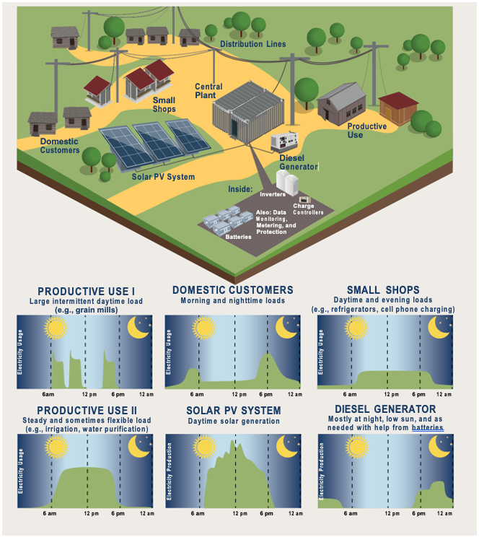

***Figure 2 — Summary of minigrid system design components and illustrative load profiles found in a minigrid***

1. **Load Profile Assessment** — To understand the load profile for the IMG community for the design of the DER solution, historical load data from the feeders and distribution transformers serving the community should be gathered. The project team can also install a power data logger to measure the power consumption of a selection of prospective IMG customers. Alternatively, if these customers have meters that store power consumption data that can be accessed by the project team or an “AMI” meter, the historical energy consumption data can be extracted from it. All this data should be combined and used to develop a load profile for the community which will be used for DER sizing and dispatch simulation.
2. **Technical Modelling** — The project team should design an optimal, least-cost, high-reliability DER solution for the community. A hybrid DER system consisting of solar, battery and backup diesel generators will likely be the most cost-effective solution. Tools like Homer Pro[8] and System Advisor Model[9] can be used to design the system. The ***Homer resources for DER system design*** included in the DER Toolkit provide introductory resources such as a training video and a user manual to help users get started with the software.
3. **Economic and Financial Modelling** – To determine a viable minigrid tariff, the project team will run an economic model that factors in projected capital costs and operational expenses and determines the economic viability of the designed solution for customers in the community, the developer and the DisCo. The project team can use the ***IMG Financial Model Template***, and the ***Benchmark costs document*** for modelling.

**Step 6 — Developer Selection**

The next step is to procure a developer to execute the Interconnected minigrid[10]. The detailed steps involved in attracting and selecting the most qualified developer to implement the project are[11]:

1. **Request for Qualification (RFQ) –**  The project team will issue an RFQ to identify a pool of pre-qualified developers who will be eligible to receive a more detailed Request for Proposals (RFP). The RFQ will assess developers based on their project implementation track record, commercial history, financial capabilities, reputation, and integrity, among other qualification factors. The team can use the ***RFQ template*** and evaluate developers using the ***RFQ scoring matrix*** included in the toolkit.
2. **Site Visits –**  The project team should conduct site visits to the area with pre-qualified developers to improve developers’ understanding of the community.
3. **Request for Proposals (RFP)–** The project team will issue an RFP to the pre-qualified developers that includes all the relevant data on the IMG community, and select the winning developer to develop the IMG. The team can use the ***RFP template*** and evaluate proposals using the ***RFP scoring matrix*** included in the toolkit.

## Execution

|  |  |  |  |  |
| --- | --- | --- | --- | --- |
| **Phase III:** | **Execution** |  | **Duration:** | **3 months+** |
| **Key steps for developers and DisCos** | | | | |
|  | | | | |
| **DER Toolkit resources** | | | | |
| * *IMG Model Term Sheet* * *IMG Tripartite Agreement* * *Project Execution Workplan* | | | | |

**Step 7 — Tripartite agreement negotiation and signing**

Once a developer is selected, the project team will need to negotiate and agree upon the terms of a tripartite agreement with the community and the developer. The important terms to align on include the final system design, tariff schedule and conditions for review, system availability, system reliability and underperformance clauses. All parties can agree on transaction terms using the ***IMG Model Term Sheet*** before modifying the ***IMG Tripartite Agreement Template.*** Once the agreement is reviewed and approved by all parties, the project team will coordinate the tripartite signing of the agreement.

**Step 8 — Regulatory approval**

T*o* obtain regulatory approval, the project team will coordinate with the selected developer to submit the tripartite agreement to the Nigerian Electricity Regulation Commission (NERC) together with supporting documentation as described in the ***Appendix 4.1.*** as part of an application for NERC’s approval by the developer.

**Step 9 — System construction and implementation of distribution network upgrades**

The project team will support the project developer in sourcing financing and procuring DER and grid upgrade components. They will oversee the construction of the DER system at a suitable location in the community and the implementation of the distribution network upgrades.[12] The ***Project Execution Workplan*** template can be modified and used to manage project construction.

**Step 10 — Interconnection, Testing and Commissioning**

Effective interconnection between the DER system and the main grid is a crucial step in project construction. It is important for the DisCo's technical team and the developer to work closely to ensure successful interconnection based on the agreed-upon system designs and standards. To ensure smooth operations, key issues such as retrofitting or installing transformers, poles, distribution cables, and meters, as well as implementing appropriate control, switching, and protection systems between the grid and DER system, must be addressed effectively and tested before commissioning.

After completing all the installation work, the entire system needs to undergo final testing and commissioning. The commissioning process involves testing the different modes of operation of the IMG, such as grid-connected mode and off-grid mode. It also includes training and handover from the technical installing teams or EPC to the developer’s operations team, signoff and acceptance by the DisCo, and handover of all previous DisCo operations to the developer. Finally, the developer has to obtain final certification from the Nigerian Electricity Management Service Agency (NEMSA)[13].

**Step 11— Operations**

The project team will work together with the project developer to ensure the project runs smoothly and the terms of the tripartite agreement are fulfilled. The DisCo will maintain the distribution network, provide the community with electricity per its obligations, and invoice the project developer for the grid electricity sold to the community. The DisCo must meet its obligations or face penalties, potentially nullifying the gains from the project.

***Table 4 — Summary of DisCo and developer roles and responsibilities for implementing an IMG project.***

|  |  |  |
| --- | --- | --- |
|  | DisCo – Led Model | |
| Steps | DisCo | Developer |
| Step 1 — IMG community shortlisting | * Analyze DisCo data to shortlist promising communities | * No role |
| Step 2 — IMG community selection | * Visit community to introduce business model * Evaluate community fit for business model | * No role |
| Step 3 — Distribution network assessment | * Conduct assessment of distribution network * Identify network upgrade requirements, associated costs and approved vendors to implement upgrades * Determine number of available hours the DisCo can commit to providing the IMG community from the bulk grid with the network upgrades * Update feeder network diagram | * No role |
| Step 4 — Community engagement | * Sign letter of interest or exclusivity agreement with community * Perform customer enumeration | * No role |
| Step 5 — DER system design | * Develop load profile for IMG community * Conduct technical modelling * Perform economic and financial modelling | * No role |
| Step 6 — Developer selection | * Issue RFQ * Assess RFQ submissions * Issue RFP * Coordinate site visit with interested developers * Assess proposals/ bids | * Review and submit response to RFQ. * Review and submit response to RFP * Visit community |
| Step 7 — Tripartite agreement negotiation and signing | * Negotiate tripartite agreement with developer and community * Get board and management approval to sign tripartite agreement * Sign and facilitates counter-signatures of tripartite agreement | * Negotiate tripartite agreement with DisCo and community * Sign tripartite agreement |
| Step 8 — Regulatory approval | * Support additional studies needed for regulators’ approval (as needed) * Review relevant documents for regulatory approval to ensure quality and compliance | * Conduct additional studies needed for regulators’ approval * Apply for regulator’s license or permit |
| Step 9 — System construction and implementation of distribution network upgrades | * Implement distribution network upgrades * Oversee construction of system | * Construct system * Finance and implement distribution network upgrades |
| Step 10 — Interconnection, testing and commissioning | * Implement interconnection systems * Test and ensure system complies with technical standards and connection agreements * Commission system | * Implement interconnection systems * Test and ensure system complies with technical standards and connection agreements |
| Step 11 — Operations | * Maintain distribution network * Invoice developer for electricity sales | * Operate and maintain DER system assets * Ensure adequate service to the community * Carry out billing and collections |

## Expected Timeline

Efficient and timely implementation of the project is of utmost importance as it can significantly impact customer engagement and satisfaction. The project timeline provides a detailed overview of the expected duration for each step involved in the project, from initiation to execution.

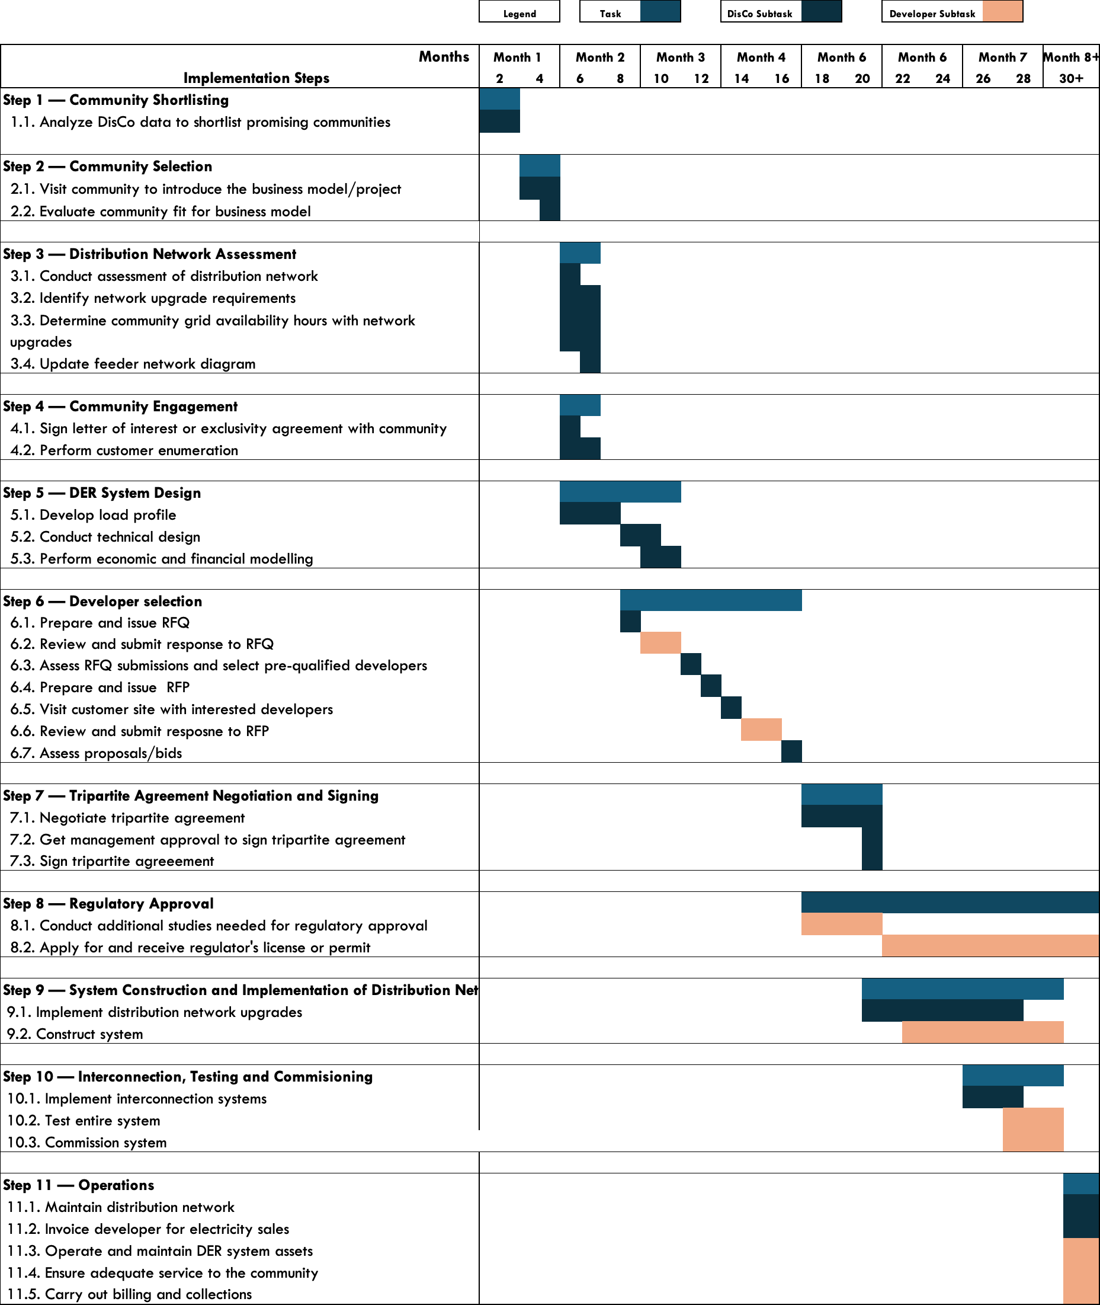

***Table 5 — Expected Timeline***

## Implementation Risks and Mitigation Strategies

It is important to identify potential risks that could inhibit the successful and timely completion of an IMG project and develop strategies to lessen the negative impact of these risks. Below is a list of the principal external risks identified as having a combination of a reasonable likelihood of occurrence and significant negative impact on the implementation of an IMG project.

***Table 3: Implementation risks and mitigation strategies***

|  |  |  |
| --- | --- | --- |
| Risks | Description | Mitigation |
| Data Inadequacy | Risk that DisCo does not have enough data to:   * Shortlist the right community * Estimate the load profile of the community | The project team should collect as much data as possible that exists within the DisCo and validate the data through engagements with local teams and customers. Data can be extrapolated from customers and communities with similar features. |
| DisCo stakeholder skepticism | Risk exists that DisCo management and other stakeholders may not fully recognize the value of the IMG project | The project team should emphasize the needs of the IMG community and the opportunity to increase revenues and drive investments into the distribution network. The project team should leverage global success stories and proof-points of the model in engaging internal stakeholders. |
| Community skepticism | Risk that project deployment is hindered due to high level of skepticism expressed by the community towards the solution | The project team should manage community relationships effectively, proactively addressing customer concerns as they arise. The selected developer should effectively communicate their track record of deploying similar systems to similar communities across various geographies and should lead community engagement alongside the DisCo |
| Lack of capacity to effectively design the DER system | Risk that the DisCo lacks the capacity to design optimal DER systems | The project team can hire a technical partner as a contractor with expertise to design the DER systems using state of art tools. |
| Subpar bids & proposals received during the RFQ & RFP stages | Risk that during the RFQ & RFP stage, the bids from interested developers do not meet the standards required by the DisCos | The DisCo should ensure that a long list of up to 10 developers with the right capacity and proven track record receive the RFQ and RFP. The team should ensure a diligent evaluation against a robust criteria using the RFP and RFQ evaluation templates |
| Tension between parties | Risk that on one or more of the parties: Community, Developer and DisCo are uncomfortable with terms of the tripartite agreement | The project team should manage community and developer relationships effectively, proactively addressing community and developer concerns as they arise. The DisCo and developer should be flexible in making changes to the project and agreement structure in the spirit of ensuring a win-win-win for all parties. The developer should support the DisCo in negotiating tariffs with the community based on proven experience of executing projects with higher tariffs. |
| Schedule risk | Risk that project execution takes too long due to:   * Long project preparation timeline * Procurement and logistics during construction * Developer capacity | The project team should work with a highly qualified developer to ensure rapid implementation and help problem-solve any issues that creep up. Additionally, the team should procure long lead time items early in the process and make every effort to adhere to the timelines outlined in this implementation plan. To manage project construction, the team should use the project execution workplan. |
| Speed of regulatory approval | Risk that there are delays in receiving approval from the regulator for the project | Developers who have a track record and experience receiving approvals from the regulator should be selected. The project team and the developer should initiate the regulatory approval process early and leverage on existing relationships with the regulatory agencies. |
| Misalignment on equipment choice | Risk that there is a misalignment between developer and DisCo on choice of equipment. | The project team should be fully aligned with the developer on distribution network upgrades and share an approved list of vendors to implement the upgrades. The project team and the DisCo should agree on an interconnection roles and responsibilities prior to signing the embedded generation agreement. |
| Poor/substandard project execution by DER developer | Risk that the developer does not construct project to the required standards | It is essential that the DisCo closely monitors the developer's progress throughout the project. The project team should develop a joint project execution workplan with the developer and track progress against it. The project team should also visit the site on a monthly or bi-monthly basis to inspect progress and assess the quality of installation. Additionally, having an owner's engineer that liaises closely with the developer can be beneficial in ensuring that the project is executed according to plan. |
| Foreign exchange (FX) risk | Risk that currency devaluation impacts project economics | The selected developer should raise local currency debt funding, and whenever possible, to denominate both capital and operating expenditures in the same currency. The project team should ensure prompt tariff adjustments in line with inflation, FX devaluation and other economic indices. |

***Contacts:***

Fola Aminu, [faminu@rmi.org](mailto:faminu@rmi.org)

Alberto Rodriguez, [arodriguez@rmi.org](mailto:arodriguez@rmi.org)

## Appendix

## IMG Implementation Timeline



## Appendix B — Regulatory Action Plan: Steps for achieving compliance with all institutional, legal, regulatory and standards requirements, including all necessary approvals, certifications and permits and their typical timeline

1. Regulatory Process for the deployment of Interconnected Minigrids with NERC Mini-Grid Regulation (2016) as the guiding regulation[14]

To deploy a DER solution under this business model, the guiding regulation is the NERC Mini-Grid Regulation (2016).[15] A The diagram (Figure 1) below outlines the regulatory process the project developer needs to follow, as required by the NERC Mini-Grid Regulation (2016). Table 1 further elaborates on the regulatory process step-by-step. Once NERC approves the Tripartite Agreement, the project developer can begin construction of the DER system and the Tripartite Agreement will be officially legally binding.[16]

***Figure 1 and Table 1 Regulatory process to deploy solutions that are less than 1MW***

1. Identify underserved community

3. Develop and sign tripartite agreement with community and DisCo

4. Submit Tripartite Agreement to NERC together with supporting documentation

2. Sign optional exclusivity agreement with community and undertake studies

The project developer reviews and resubmits application

The project developer can install and operate DER system

Within 30 days, update agreement based on feedback from NERC

(If NERC approves)

(If NERC intends to refuse)

| No | Action | Description |
| --- | --- | --- |
| 1 | Identify underserved community | Using the site selection criteria, the project developer and DisCo should identify a suitable community that closely matches the preferred community characteristics and is interested in the utility-enabled solution. |
| 2 | Sign exclusivity agreement with community to undertake studies | The project developer can sign an exclusivity agreement for up to 12 months with the community to conduct technical and feasibility studies for the solution. While this is optional according to the regulation, the mini-grid online application portal requires applicants to submit an exclusivity agreement. |
| 3 | Develop and sign tripartite agreement with community and DisCo | Based on the solution's technical and financial design, the project developer should prepare a tripartite agreement with the details of the solution, ensure alignment with the DisCo and the community on the terms and conditions and have all parties sign the agreement |
| 4 | Submit Tripartite Agreement to NERC together with supporting documentation | The project developer should submit the tripartite agreement to NERC together with the supporting documentation described in 1.1 (below) as part of an application for NERC’s approval. The application shall be addressed to the Secretary of the Commission, and delivered by hand or sent by regular mail or courier to the Commission’s headquarters. The Agreement, which forms the application for the mini-grid, shall be signed and dated by the project developer. The application shall be submitted in three paper copies and an electronic version in Microsoft Office software format. Alternatively, the project developer can submit an application via the NERC mini-grid online application portal[17] |

* 1. Supporting Documentation needed for NERC’s approval of the Tripartite Agreement

When requesting NERC’s approval of the Tripartite Agreement, the project developer, as the Mini-Grid Operator, is required to submit the following documents to receive NERC approval to install and commission a mini-grid system.

***Table 2: Supporting document needed for NERC’s approval in accordance with the Mini-Grid Regulation***

| No | Document(s) | Description |
| --- | --- | --- |
| 1 | Certified copy of Certificate of Incorporation, Memorandum and Articles of Association, Deed of Partnership or Deed of Trust, as applicable | These documents prove that the project developer is a registered entity in Nigeria. The documents can be processed through the Corporate Affairs Commission (CAC) |
| 2 | Filled Standardized Spreadsheets for Tariff Calculation | The project developer is required to fit project tariffs to the standardized mini-grid MYTO tariff model and present it to NERC. The spreadsheet can be found on the NERC’s website[18] |
| 3 | Environmental and Social Management Plan (ESMP) | NERC does not require an ESMP, but this should be prepared and submitted as proof that the project complies with the existing environmental regulation. |
| 4 | Certified copy of Building Permit | A building permit is an official approval to proceed with a construction project. While it is a required document by NERC, people familiar with the matter posit that a lease agreement should be sufficient. |
| 5 | Power station layout drawings, which can be included in the tripartite contract. | |
| 6 | Map with the position of power station and distribution network marked using indicators to distinguish single phase and three phase as well as medium voltage networks, which can be included in the tripartite contract. | |
| 7 | Lease Agreement, which can be included in of the tripartite contract, if applicable. | |

* 1. Major obligations in accordance with the Mini-Grid Regulation

The project developer is required to carry out its obligations in accordance with the *Mini-Grid Regulation*5. The tableTable 3 below summarizes the major obligations

***Table 3: Major obligations in accordance with the Mini-Grid Regulation***

| No | Obligation(s) | Description |
| --- | --- | --- |
| 1 | Maintain Separate Accounts | The project developer is required to maintain a separate account for the mini-grid business and prepare accounting statements on the mini-grid business for each fiscal year |
| 2 | Periodic Tariff Reviews | The project developer is required to provide account information on the mini-grid system at least once every two years to allow NERC to review the mini-grid tariff. The project developer shall provide these reports in the form prescribed in Annex 4 of the *Mini-Grid Regulation5.* NERC can adjust the tariffs based on the mini-grid MYTO methodology inputs  The Mini-grid community can also trigger the adjustments of tariff by requesting an inspection of accounts by NERC. |
| 3 | Installation and Maintenance | The project developer is required to install and operate the solution in compliance with the technical codes and standards approved by NERC, as well as the terms and conditions of the tripartite contract. |
| 4 | Safety and Environmental Protection | The project developer is required to comply with the safety guidelines prescribed in Annex 6 of the *Mini-Grid Regulation5* and existing environmental legislation |
| 5 | Dispute Resolution | The project developer is required to follow the Dispute Resolution Mechanism in Annex 10 of the *Mini-Grid Regulation5* for all disputes arising from or in connection with the Mini-grid. Disputes arising between the project developer, the DisCo and the community unable to be resolved by the parties shall be resolved by NERC through a dispute resolution counsellor (DRC) or a dispute resolution panel (DRP). NERC is amenable to the use of alternate dispute resolution mechanisms e.g., the expert determination process in the tripartite contract, as long all parties agree and sign-up to the process. |

In addition, the project developer is required to install and operate this solution in accordance with good industry practice, standards set out by the Standards Organization of Nigeria and other best practices that The project developer typically meets as a DER developer.

1. If developers want to work with a specific community to develop an IMG, they can reach out to a DisCo directly. The DisCo can verify if the community is a suitable fit and allow the developer to lead most of the implementation steps, with the DisCo providing support.
2. The preferred community characteristics are considered desirable but not mandatory.
3. 4 5 Guideline values based on RMI analysis
4.
5.
6. If there is a preferred developer for the project, the project team can choose to have the developer lead this step while the DisCo supports the developer, validates the output of the study and determines the number of available hours that can be supplied to the community if the recommended network upgrades are implemented.
7. The project team can choose to skip this step, proceed to the developer selection step and have the selected developer complete the design of the DER system while the project team validates the system design with a focus on the system interconnection to the distribution network.
8. https://www.homerenergy.com/products/pro/index.html
9. https://sam.nrel.gov/
10. Ideally, the project team will procure a developer or developers for a lot of REG, C&I and IMG projects
11. While strongly recommended, developers do not have to be competitively procured. If the project team has a preferred developer, this step can be skipped.
12. The DisCo can choose to finance and implement the distribution network upgrades, or the developer can finance and implement the upgrades while the DisCo ensures compliance with the required standards.
13. NEMSA is the regulator responsible for certifying electrical installations meet technical standards in Nigeria.
14. For solutions greater than 1MW, it is possible to classify them as multiple minigrids and get multiple minigrid permits.
15. Nigerian Electricity Regulatory Commission, *Regulations for Mini-Grids*, NERC, 2016, <https://nerc.gov.ng/index.php/library/documents/Regulations/NERC-Regulation-for-Mini-Grid/>
16. NERC approving the tripartite agreement is the equivalent of getting a permit for isolated mini-grids.
17. NERC mini-grid online application portal – [https://mini-grid.nerc.app](https://minigrid.nerc.app)
18. Nigerian Electricity Regulatory Commission Mini Grid MYTO Model 2021, NERC, 2021 <https://nerc.gov.ng/index.php/library/documents/Regulations/Mini-Grid-MYTO-Model-2021/>