Implementation Plan Template for Commercial & Industrial Utility-Enabled Distributed Energy Resources Business Model

MAY 2024

Note to readers:
This project implementation plan template has been designed by RMI with support from the Global Energy Alliance for People and Planet (GEAPP) as part of a distributed energy resource (DER) toolkit that aims to accelerate DER project development in Nigeria. This is a draft document which has been released to obtain feedback from potential users.

Introduction
This implementation plan template outlines the steps, processes, and recommendations for the timely identification, development and execution of the Utility-Enabled Distributed Energy Resources Business Model for large Commercial and Industrial customers (UEDER C&I or C&I) from project initiation to operations. This implementation plan is part of the Distributed Energy Resources Toolkit (DER Toolkit) that RMI developed to support Electric Distribution Companies (DisCos) and DER developers in implementing utility-enabled DERs. The toolkit includes several resources and templates that Electric Distribution Companies (DisCos) can reference and modify for use in their own utility-enabled-DER projects.

This document lays out the key steps an Electric Distribution Company (DisCo) should take to implement a UEDER C&I project successfully. Section 2 provides an overview of the main implementation steps, from initiation to execution, including the roles and responsibilities of DisCos and DER project developers (“developer”), as well as the recommended timelines for each step. Lastly, Section 3 discusses the key risks that need to be addressed, along with proposed mitigation strategies.

Figure 1 — Summary of the utility-enabled C&I business model

This document…
- is for utility leaders who want to meet the reliability needs of their large commercial and industrial customers
- will help readers understand the steps required to initiate, prepare and execute an utility-enabled C&I project
- includes advice on defining responsibilities between utilities and DER project developers
- prepares you to understand how long it will take to complete each steps, and how you can mitigate common risks along the way
- outlines the steps for achieving compliance with all institutional, legal, regulatory and standards requirements, including all necessary approvals, certifications and permits and their typical timeline

Implementation Phases and Steps for Projects
There are three main phases in the implementation of a C&I project: initiation, preparation, and execution. These steps are led by a team within the DisCo (the project team) and are further described below. If the project team feels that the developer is better suited to lead a particular step, it can delegate that step to the developer but ultimately the DisCo is responsible for overseeing the process and should endeavour to lead these steps.

Table 1 — Summary of the business model implementation process for DisCo-led projects

Phase | Description
Initiation Phase | - The utility will identify potential customers needing reliable power and initiate engagement to gauge interest and business model fit.
Preparation Phase | - The utility will conduct technical assessment, design a DER solution, select a developer, and finalize the DER solution design alongside the selected developer.
Execution Phase | - The utility, the developer and the customer will sign a final contract. The system will be constructed and the distribution network upgrades will be implemented. Services to the customer will be initiated based on the terms of the agreement.

Overview of implementation steps

Initiation
Phase I: | Initiation |  | Duration: | 1 month
Key steps for developers and DisCos
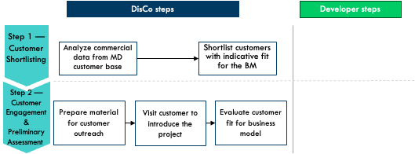
DER Toolkit resources
- Data collection methodology for identification and de-risking DERs
- C&I Information Brief

Step 1 — Customer shortlisting

The first step in implementing a C&I project is to identify potential customers. The project team should analyze commercial data from their large C&I and Maximum Demand (MD) customers, engage area offices, business districts and MD customer managers and shortlist customers who have a high energy spend and have had complaints about their power supply gap. These customers should also express a strong need for improved power supply availability. The exact data required, their sources and recommendations for improving the availability of this data can be found in the Data collection methodology for identification and de-risking DERs included in the Toolkit.

Step 2 — Customer engagement & preliminary assessment

Once a few customers are shortlisted, the next step in implementing a C&I project is to identify a promising C&I customer that meets certain criteria that make them a good fit for the business model. The project team should visit potential customers to introduce the business model and assess their suitability for the business model. Customers who closely match the preferred customer criteria in Table 1 would be a good fit for the business model.

Table 2 — Preferred customer characteristics
 | Criteria ​ | Preferred customer characteristics​
Very important | Current grid hours of supply ​ | Customer receives less than 12 hours of daily electricity supply from the grid ​
Very important | Significant daytime electricity use & evidence of partial grid defection ​ | Customer uses a diesel generator rated at 75 kVA or higher and operates primarily in daytime hours. ​
Very important | Physical appropriateness of site for DERs​ | Customer has a minimum of ~500m² in available rooftop and/or land space for solar PV installation​
Very important | Customer interest ​ | Customer shows enthusiasm for a DER solution and is willing to sign a long-term contract ​
Important | Ease of customer engagement and data collection ​ | Customer has data available or allows for easy data collection​
Important | Implementation period​ | Customer has a simplified decision-making structure that would shorten project timeline; customer might have sustainability goals that encourage action​
Important | Customer grouping dynamics ​ | Customer is closely located around other large C&I customers ​

The project team can use the C&I Information Brief included in the Toolkit to engage customers and collect data. Customers who closely meet the above criteria should move to preparation.

Preparation
Phase II: | Preparation |  | Duration: | 3 months
Key steps for developers and DisCos
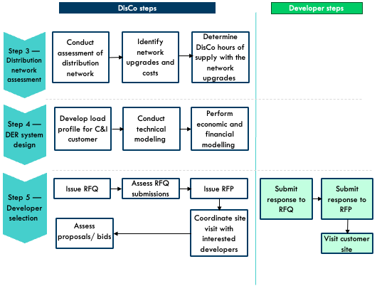

DER Toolkit resources
- Distribution Network Assessment Template
- Homer resources for DER system design
- C&I Financial Model Template
- Benchmark costs document
- RFQ template and RFQ evaluation template
- C&I RFP template and RFP evaluation template

Step 3 — Distribution network assessment

Once a promising C&I customer is identified, the project team should conduct a study to determine the most cost—effective way to upgrade the distribution network to improve reliability for the C&I customer. These studies should produce the distribution network upgrades needed, their associated costs, approved vendors that can carry out the upgrades and the number of hours of electricity supply that can be guaranteed to the customer if these upgrades are implemented. The project team can use the Distribution Network Assessment Template to guide this process.

Step 4 — DER system design

The next step in the process is to design an optimal DER system for the customer under consideration. The output of this process is a proposal that includes the system design and blended tariff for the project. Below are the detailed steps involved in this process.

- Load profile assessment – To gather an accurate load profile for the C&I customer to model and design the DER solution. The project team should install a power data logger to measure the power consumption of the facility at a granular basis for two weeks to a month. Alternatively, if the customer has a meter that stores power consumption data that can be accessed by the project team or an “AMI” meter, the historical energy consumption data can be extracted from it. This logged data should be used to extrapolate the “typical” week and develop a load profile for system design, which will be used for DER sizing and dispatch simulation.

Figure 1 — Average daily load profile of a sample C&I customer, source: RMI

- Technical modeling – The project team should design an optimal least-cost, high-reliability DER solution for the customer. A solar-battery-diesel hybrid DER solution will likely be the most cost-effective solution. Customers with large consumption and/or access to gas infrastructure may use gas generators in the system. Tools like Homer Pro and System Advisor Model can be used to design the DER system. The Homer resources for DER system design included in the DER Toolkit provides introductory resources such as a training video and a user manual to help users get started with the software.

Figure 2 — Optimal system design for a sample C&I customer, source: RMI

- Economic and financial modelling – To determine a viable tariff for the customer under consideration, the project team should run an economic model that factors in projected capital costs and operational expenses and determines the economic viability of the designed solution for the customer, the developer and the DisCo. The project team can use the C&I Financial Model Template and the Benchmark Costs document for modelling.

Step 5 — Developer selection

The next step is to procure a developer to execute the C&I project. The detailed steps involved in attracting and selecting the most qualified developer to implement the C&I project are:

- Request for qualification (RFQ) — The project team will issue an RFQ to identify a pool of pre-qualified developers who will be eligible to receive a more detailed Request for Proposals (RFP). The RFQ will assess developers on their project implementation track record, their commercial history, their financial capabilities, and their reputation/integrity, among other qualification factors. The team can use the RFQ Template and evaluate developers using the RFQ evaluation template included in the toolkit.
- Site visits — The project team should conduct site visits to the customer with pre-qualified developers to improve developers’ understanding of the customer.
- RFP — The project team will issue an RFP to the pre—qualified developers that includes all the relevant data on the customer. The team can use the RFP Template and evaluate proposals using the RFP evaluation template included in the toolkit.

Execution

Phase III: | Execution |  | Duration: | 3 months+
Key steps for developers and DisCos
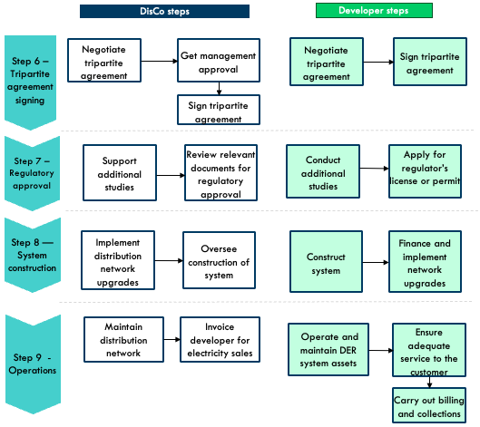

DER Toolkit resources
- C&I Model Term Sheet
- C&I Tripartite Agreement
- Project Execution Workplan

Step 6 — Tripartite agreement negotiation and signing

Once a developer is selected, the project team will need to negotiate and agree upon the terms of a tripartite agreement with the customer and the developer. The important terms to align on include the final system design, tariff schedule and conditions for review, system availability, system reliability and underperformance clauses. All parties can agree on transaction terms from the C&I Model Term Sheet before modifying the C&I Tripartite Agreement Template. Once the agreement is reviewed and approved by all parties, the project team will coordinate the tripartite signing of the agreement.

Step 7 — Regulatory approval
To get regulatory approval, the project team will coordinate with the selected developer to submit the tripartite agreement to the Nigerian Electricity Regulation Commission (NERC) together with supporting documentation as described in the C&I Regulatory Action Plan in Appendix A as part of an application for NERC’s approval by the developer.

Step 8 — System construction and implementation of distribution network upgrades

The project team will work alongside the project developer to source financing, procure DER and grid upgrade components, oversee the construction of the DER system at the client’s facility and implement the distribution network upgrades. The Project Execution Workplan template can be modified and used to manage project construction.

Step 9 — Operations

The project team will work together with the project developer to ensure the project runs smoothly and the terms of the tripartite agreement are fulfilled. The DisCo will maintain the distribution network and, provide the customer with electricity per its obligations and invoice the project developer for grid electricity sold to the customer. The DisCo must meet their obligations or face penalties, potentially nullifying the gains from the project.

Roles and responsibilities for implementation steps
During project implementation, DisCos and developers have crucial roles. Table 2 outlines each party's key responsibilities, while Figure 3 displays the process flowchart.

Table 2 — DisCo and developer roles and responsibilities for implementing a UEDER C&I project.
 | DisCo – led model
Steps | DisCo | Developer
Step 1 – Customer shortlisting | - Analyze commercial data from large C&I customer/ MD customer base  - Shortlist customers who have a high energy spend and have had complaints about their power supply gap | - No role
Step 2 — Customer engagement & preliminary assessment | - Prepare customer engagement material for initial outreach  - Visit customer to introduce business model  - Evaluate customer fit for business model | - No role
Step 3 — Distribution network assessment | - Conduct assessment of distribution network  - Identify network upgrade requirements, associated costs and approved vendors to implement upgrades  - Determine number of available hours the DisCo can commit to providing the customer with the network upgrades | - No role
Step 4 – DER system design | - Develop load profile  - Conduct technical design  - Perform economic and financial modelling | - No role
Step 5 – Developer selection | - Issue RFQ  - Assess RFQ submissions  - Issue RFP  - Coordinate site visit with interested developers  - Assess proposals/ bids | - Review and submit response to RFQ.  - Review and submit response to RFP  - Visit customer site
Step 6 – Tripartite agreement negotiation and signing | - Negotiate tripartite agreement with developer and customer  - Get board and management approval to sign tripartite agreement  - Sign and facilitates counter—signatures of tripartite agreement | - Negotiate tripartite agreement with DisCo and customer  - Sign tripartite agreement
Step 7 – Regulatory approval | - Support additional studies needed for regulators’ approval (as needed)  - Review relevant documents for regulatory approval to ensure quality and compliance | - Conduct additional studies needed for regulators’ approval (as needed)  - Apply for regulator’s license or permit (as needed)
Step 8 – System construction and implementation of distribution network upgrades | - Implement distribution network upgrades  - Ensure interconnection complies with technical standards  - Oversee construction of system | - Construct system in accordance with good industry practice and standards  - Finance distribution network upgrades  - Conduct performance testing on network upgrades and availability
Step 9 — Operations | - Maintain distribution network  - Invoice developer for electricity sales | - Operate and maintain DER system assets  - Ensure adequate service to the customer  - Carry out billing and collections

Expected timeline
Efficient and timely implementation of the project is of utmost importance as it can significantly impact customer engagement and satisfaction. The proposed project timeline template provides a detailed overview of the expected duration for each step involved in the project, from initiation to execution.

Table 2 Expected Timeline

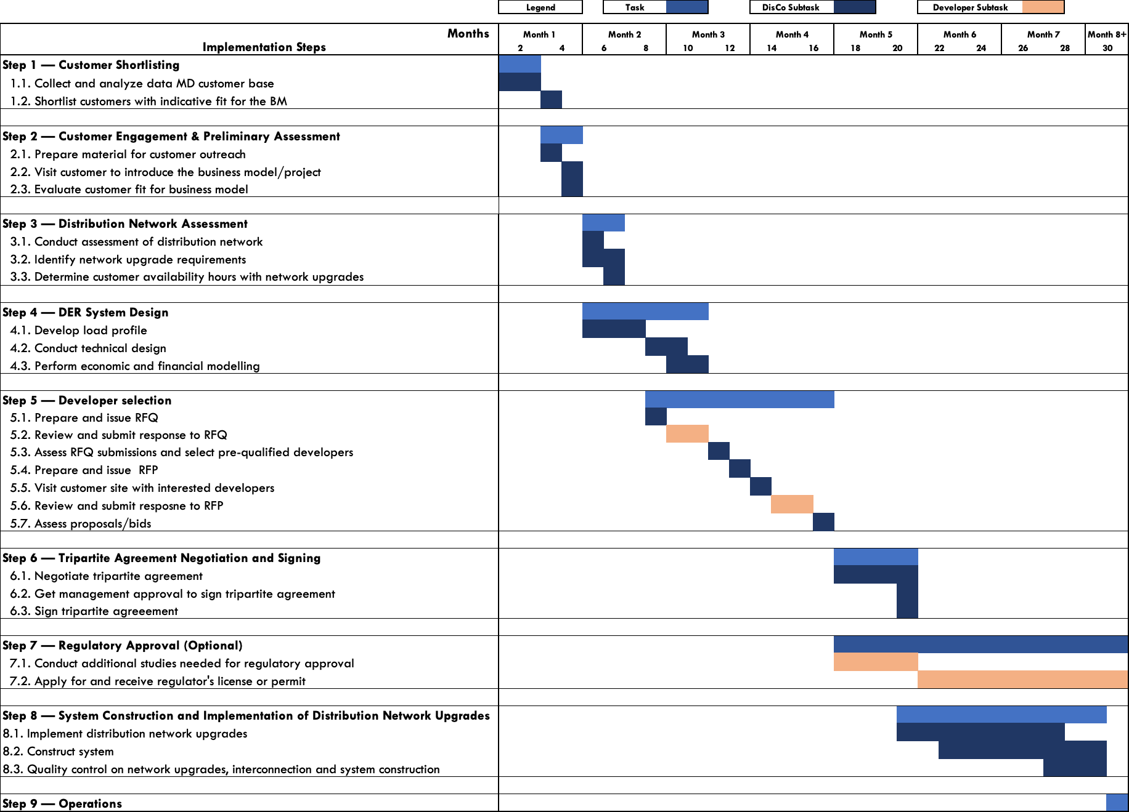

Implementation risks and mitigation strategies
It is important to identify potential risks that could inhibit the successful and timely completion of the projects and develop strategies to lessen the negative impact of these risks. Below is a list of the principal external risks identified as having a combination of a reasonable likelihood of occurrence and significant negative impact on the implementation of a C&I project, along with some proposed mitigation strategies.

Table 3: Implementation risks and mitigation strategies
Risks | Description | Mitigation
Project initiation
Data Inadequacy | Risk that DisCo does not have enough data to shortlist the right customers | The project team should collect as much data as possible that exists within the DisCo and validate the data through engagements with the customer. Data can be extrapolated for customers with similar features.
Project preparation
Customer scepticism | Risk that project deployment is hindered due to high level of risk aversion around power supply of C&I customer | The project team should ensure the right kind of customer is selected based on their preliminary assessment, engage extensively with customers in designing the DER systems to improve their power reliability and reduce their cost. The project team should manage customer relationships effectively, proactively addressing customer concerns as they arise. The selected developers should effectively communicate their track record of deploying similar systems to commercial and industrial customers across various geographies.
Lack of technical capacity to effectively design the DER system | Risk that the DisCo lacks the technical capacity to design optimal DER systems | The project team can hire a technical partner as a contractor to design the DER system using state of art tools like Homer Pro.
Subpar bids & proposals received during the RFQ & RFP stages | Risk that during the RFQ & RFP stage, the bids from interested developers do not meet the standards required by the DisCos | The DisCo should ensure that a long list of up to 10 developers with the right capacity and proven track record receive the RFQ and RFP. The team should ensure a diligent evaluation against robust criteria using the RFP and RFQ evaluation templates. The DisCo team can provide bidders with the evaluation criteria and an example proposal.
Tension between parties | Risk that on one or more of the parties: Customer, Developer or DisCo are uncomfortable with terms of tripartite agreement | The project team should manage customer and developer relationships effectively, proactively addressing customer and developer concerns as they arise. The DisCo and developer should be flexible in making changes to the project and agreement structure in the spirit of ensuring a win-win-win for all parties.
Project execution
Schedule risk | Risk that project execution takes too long due to:  - Long project preparation timeline  - Procurement and logistics during construction  - Developer capacity | The project team should work with a highly qualified developer to ensure rapid implementation and help problem-solve any issues that creep up. Additionally, the team should procure long lead time items early in the process and make every effort to adhere to the timelines outlined in this implementation plan. To manage project construction, the team should use the project execution workplan.
Speed of regulatory approval | Risk that there are delays in receiving approval from the regulator for the project | Developers who have a track record and experience receiving approvals from the regulator should be selected.
Misalignment on equipment choice | Risk that there is a misalignment between developer and DisCo on choice of equipment. | The project team should be fully aligned with the developer on distribution network upgrades and share an approved list of vendors to implement the upgrades. The project team and the DisCo should agree on an interconnection roles and responsibilities prior to signing the tripartite agreement.
Poor/substandard project execution by DER developer | Risk that the developer does not construct project to the required standards | It is essential that the DisCo closely monitors the developer's progress throughout the project. The project team should develop a joint project execution workplan with the developer and track progress against it. The project team should also visit the site on a monthly or bi-monthly basis to inspect progress and assess the quality of installation. Additionally, having an owner's engineer that liaises closely with the developer can be beneficial in ensuring that the project is executed according to plan.
Customer apathy | Risks that customer is no longer interested in pursuing project to implementation | The project team should manage customer relationships effectively, proactively addressing customer concerns as they arise. The project team should ensure the value proposition of the project to the customer is well communicated.

Contacts:
Fola Aminu, faminu@rmi.org
Alberto Rodriguez, arodriguez@rmi.org

Appendix

Appendix A — Implementation Timeline
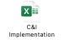

Appendix B — Regulatory Action Plan: Steps for achieving compliance with all institutional, legal, regulatory and standards requirements, including all necessary approvals, certifications and permits and their typical timeline

- Regulatory Process for the deployment of solutions less than 1MW in capacity with the NERC Mini-Grid Regulation (2016) as the guiding regulation

To deploy a DER solution less than 1 MW in capacity under this business model, the guiding regulation is the NERC Mini-Grid Regulation (2016). A solution less than 1 MW under this business model can be classified as an interconnected mini-grid. The diagram (Figure 1) below outlines the regulatory process the project developer needs to follow, as required by the NERC Mini-Grid Regulation (2016). Table 1 further elaborates on the regulatory process step-by-step. Once NERC approves the Tripartite Agreement, the project developer can begin construction of the DER system and the Tripartite Agreement will be officially legally binding.

Figure 1 and Table 1 Regulatory process to deploy solutions that are less than 1MW
1. Identify underserved Large Commercial & Industrial Customer
3. Develop and sign tripartite agreement with customer and DisCo
4. Submit Tripartite Agreement to NERC together with supporting documentation
2. Sign exclusivity agreement with customer to undertake studies
The project developer reviews and resubmits application
The project developer can install and operate DER system
Within 30 days, update agreement based on feedback from NERC
(If NERC approves)
(If NERC intends to refuse)

No | Action | Description
1 | Identify underserved large commercial & industrial customer | Using the site selection criteria, the project developer should identify a suitable large commercial or industrial customer who fits the site selection criteria and is interested in the utility-enabled solution. The project developer should propose the project to the licensed distribution company (DisCo) that serves the customer or serves the customer’s catchment area and get the DisCo’s approval.
2 | Sign exclusivity agreement with community (C&I customer) to undertake studies | The project developer can sign an exclusivity agreement for up to 12 months with the large commercial or industrial customer to conduct technical and feasibility studies for the solution. While this is optional according to the regulation, the mini-grid online application portal requires applicants to submit an exclusivity agreement.
3 | Develop and sign tripartite agreement with customer and DisCo | Based on the solution's technical and financial design, the project developer should prepare a tripartite agreement with the details of the solution, ensure alignment with the DisCo and the customer on the terms and conditions and have all parties sign the agreement
4 | Submit Tripartite Agreement to NERC together with supporting documentation | The project developer should submit the tripartite agreement to NERC together with the supporting documentation described in 1.1 (below) as part of an application for NERC’s approval. The application shall be addressed to the Secretary of the Commission, and delivered by hand or sent by regular mail or courier to the Commission’s headquarters. The Agreement, which forms the application for the mini-grid, shall be signed and dated by the project developer. The application shall be submitted in three paper copies and an electronic version in Microsoft Office software format. Alternatively, the project developer can submit an application via the NERC mini-grid online application portal

  - Supporting Documentation needed for NERC’s approval of the Tripartite Agreement
When requesting NERC’s approval of the Tripartite Agreement, the project developer, as the Mini-Grid Operator, is required to submit the following documents to receive NERC approval to install and commission a mini-grid system.

Table 2: Supporting document needed for NERC’s approval in accordance with the Mini-Grid Regulation
No | Document(s) | Description
1 | Certified copy of Certificate of Incorporation, Memorandum and Articles of Association, Deed of Partnership or Deed of Trust, as applicable | These documents prove that the project developer is a registered entity in Nigeria. The documents can be processed through the Corporate Affairs Commission (CAC)
2 | Filled Standardized Spreadsheets for Tariff Calculation | The project developer is required to fit project tariffs to the standardized mini-grid MYTO tariff model and present it to NERC. The spreadsheet can be found on the NERC’s website
3 | Environmental and Social Management Plan (ESMP) | NERC does not require an ESMP, but this should be prepared and submitted as proof that the project complies with the existing environmental regulation.
4 | Certified copy of Building Permit | A building permit is an official approval to proceed with a construction project. While it is a required document by NERC, people familiar with the matter posit that a lease agreement should be sufficient.
5 | Power station layout drawings, which can be included in the tripartite contract.
6 | Map with the position of power station and distribution network marked using indicators to distinguish single phase and three phase as well as medium voltage networks, which can be included in the tripartite contract.
7 | Lease Agreement, which can be included in of the tripartite contract, if applicable.

  - Major obligations in accordance with the Mini-Grid Regulation
The project developer is required to carry out its obligations in accordance with the Mini-Grid Regulation⁵. The tableTable 3 below summarizes the major obligations

Table 3: Major obligations in accordance with the Mini-Grid Regulation
No | Obligation(s) | Description
1 | Maintain Separate Accounts | The project developer is required to maintain a separate account for the mini-grid business and prepare accounting statements on the mini-grid business for each fiscal year
2 | Periodic Tariff Reviews | The project developer is required to provide account information on the mini-grid system at least once every two years to allow NERC to review the mini-grid tariff. The project developer shall provide these reports in the form prescribed in Annex 4 of the Mini-Grid Regulation⁵. NERC can adjust the tariffs based on the mini-grid MYTO methodology inputs  The Mini-grid customer can also trigger the adjustments of tariff by requesting an inspection of accounts by NERC.
3 | Installation and Maintenance | The project developer is required to install and operate the solution in compliance with the technical codes and standards approved by NERC, as well as the terms and conditions of the tripartite contract.
4 | Safety and Environmental Protection | The project developer is required to comply with the safety guidelines prescribed in Annex 6 of the Mini-Grid Regulation⁵ and existing environmental legislation
5 | Dispute Resolution | The project developer is required to follow the Dispute Resolution Mechanism in Annex 10 of the Mini-Grid Regulation⁵ for all disputes arising from or in connection with the Mini-grid. Disputes arising between the project developer, the DisCo and the customer unable to be resolved by the parties shall be resolved by NERC through a dispute resolution counsellor (DRC) or a dispute resolution panel (DRP). NERC is amenable to the use of alternate dispute resolution mechanisms e.g., the expert determination process in the tripartite contract, as long all parties agree and sign-up to the process.
In addition, the project developer is required to install and operate this solution in accordance with good industry practice, standards set out by the Standards Organization of Nigeria and other best practices that The project developer typically meets as a DER developer.

- Regulatory Process for the deployment of solutions greater than 1MW in capacity with the NERC Embedded Generation Regulation (2012) as the guiding regulation
To deploy a solution larger than 1 MW in capacity under this business model, the guiding regulation is the NERC Embedded Generation Regulation (2012). The diagram (Figure 2) below outlines the regulatory process the project developer needs to follow, as required by the NERC Embedded Generation Regulation (2012). Table 4 further elaborates the regulatory process step-by-step. Once NERC approves the Tripartite Agreement and generation license, the project developer pays the license fee and NERC grants the license. Once this is done, the project developer can begin construction of the DER system and the Tripartite Agreement will be officially legally binding.

Figure 2 and Table 4: Regulatory process to deploy solutions with capacity larger than 1MW
1. Identify underserved Large Commercial & Industrial Customer
2. Develop and sign tripartite agreement with customer and DisCo
3. Apply for a generation license by submitting the Tripartite Agreement to NERC together with supporting documentation and the application fee
The project developer reviews and resubmits application
The project developer pays the license fee and can install and operate DER system
Within 60 days, update agreement based on feedback from NERC
(If NERC approves)
(If NERC intends to refuse)

No | Action | Description
1 | Identify underserved Large Commercial & Industrial Customer | Using the site selection criteria, the project developer should identify a suitable large commercial or industrial customer who fits the site selection criteria and is interested in the utility-enabled solution. The project developer should propose the project to the licensed distribution company (DisCo) that serves the customer or serves the customer’s catchment area and get the DisCo’s approval.
2 | Develop and sign tripartite agreement with customer and DisCo | Based on the solution's technical and financial design, the project developer should prepare a tripartite agreement that contains the various network agreements, ensure alignment with the DisCo and the customer on the terms and conditions and have all parties sign the agreement
3 | Apply for a generation license by submitting the Tripartite Agreement to NERC together with supporting documentation and the application fee | The project developer should apply for a generation license by completing the application form, submitting it together with the tripartite agreement and other supporting documentation (see 2.1 below) and paying a ₦70,000 processing fee to NERC. The application form can be found in Schedule 2 and the full list of documents needed for application in Schedule 1A and 1B in the Application for Licenses Regulation⁹. The application shall be addressed to the Chairman of the Commission, and delivered by hand or sent by regular mail or courier to the Commission’s headquarters. The application shall be submitted in three paper copies and an electronic version in Microsoft Office software format. If the application is successful, The project developer is required to pay a license fee of $5,000.

  - Supporting Documentation needed for application for Generation License and approval of the Tripartite Agreement
When applying for a generation license and requesting NERC’s approval of the Tripartite Agreement, the project developer, as the Embedded Generator, is required to submit the application form and the following documents to receive NERC approval to install the embedded generation system. All supporting documents shall be submitted in two paper copies and one electronic version.

Table 5: Supporting document needed for NERC’s granting of a generation license in accordance with the Application for Licenses Regulation
No | Document(s) | Description
1 | Certified copy of Certificate of Incorporation, Memorandum and Articles of Association, Deed of Partnership or Deed of Trust, as applicable | These documents prove that the project developer is a registered entity in Nigeria. The documents can be processed through the Corporate Affairs Commission (CAC)
2 | Off-take Agreement or Arrangement (Tripartite Agreement) | The tripartite agreement represents the off-take agreement and other network agreements.
3 | Details on how effluents and discharges will be managed or Environmental Impact Assessment (EIA) Approval Certificate, or proof of submission and acceptance for processing of the EIA Report to the Ministry of Environment. | NERC does not require an EIA report, but this should be prepared and submitted as proof that the project complies with the existing environmental regulation and should include a section on how effluents and discharges will be managed.
4 | Registered Title Deed to Site, or Sale Agreement, or Deed of Assignment/Gift, or evidence of  submission of a title deed to a relevant land processing agency (as applicable). | The lease agreement embedded in the tripartite agreement shall serve as the site permit.
5 | Tax Clearance Certificate for immediate past three (3) years | The Tax Clearance Certificate issued by Federal Inland Revenue Service, showing assessment records of the past three years.
6 | Ten-year Business Plan | A ten-year business plan that includes all the details found in Schedule 1F (2) of the Application for Licenses Regulation⁹.
7 | Details of fixed infrastructure for generation assets following the requirements for applications for generation licenses. This can be included as part of the tripartite contract.
8 | Timelines for commissioning of the power plant and the date when different capacities of the plant will come into operation. This can be included as part of the tripartite contract.
9 | Financing Agreements or Letter to fund the project from financial institution. This can be included as part of the tripartite contract, or a separate document.
10 | A memorandum of understanding (MoU) with or Letter of intent from Engineering Procurement Contract (EPC) Contractor (if applicable).
11 | MoU with or Letter of intent from the technical partner (if applicable).

  - Major Obligations in accordance with the Embedded Generation Regulation
The project developer is required to carry out its obligations in accordance with the Embedded Generation Regulation³. Table 6 below summarizes the major obligations

Table 6: Major obligations in accordance with the Embedded Generation Regulation
No | Obligation(s) | Description
1 | Annual Operating Fees | The project developer, as an embedded generation licensee shall pay 1.5% of the energy charges collected from the customer
2 | Maintain Separate Accounts | The project developer is required to maintain a separate account for the embedded generation business
3 | Prohibition from engaging in other Regulated Activities | The project developer shall not engage in the business of distribution, transmission, trading and system operations.
4 | Installation and Maintenance | The project developer is required to install and operate the solution in compliance with the technical codes and standards approved by NERC, as well as the terms and conditions of the tripartite contract.
5 | Dispute Resolution | Disputes arising between the The project developer, the DisCo and the customer unable to be resolved by the parties shall be resolved by NERC in accordance with the Dispute Resolution Procedure in Rule 43 of the Market Rules¹⁰ through either a dispute resolution counsellor (DRC), a dispute resolution panel (DRP) or the applicable Dispute Resolution Procedure approved by the Commission, from time to time. NERC is amenable to the use of alternate dispute resolution mechanisms e.g., the expert determination process in the tripartite contract, as long all parties agree and sign-up to the process.
6 | Renewal of License | The project developer shall apply for the renewal of the generation licence nine months before the expiration of the licence via the form specified in Schedule 4 of the Application for Licenses Regulation⁹.

In addition, the project developer is required to install and operate this solution in accordance with good industry practice, standards set out by the Standards Organization of Nigeria and other best practices that the project developer typically meets as a DER developer.

Customers who express interest in deploying a DER solution by approaching the DisCo directly or through a preferred DER developer and are a good fit for the business model can be selected for a project.
The preferred customer characteristics are considered desirable but not mandatory. It is recommended that each shortlisted customer be evaluated and scored using the C&I Preliminary Assessment Evaluation Template.
⁴ ⁵ These criteria were determined based on analysis conducted by RMI and should be regarded as guides or threshold values. ⁶ If there is a preferred developer for the project, the project team can choose to have the developer lead this step while the DisCo supports the developer, validates the output of the study and determines the number of available hours that can be supplied to the customer if the recommended network upgrades are implemented.
The project team can choose to skip this step, proceed to the developer selection step and have the selected developer complete the design of the DER system while the project team validates the system design with a focus on the system interconnection to the distribution network.
https://www.homerenergy.com/products/pro/index.html
https://sam.nrel.gov/
Ideally, the project team will procure a developer or developers for a lot of REG, C&I and IMG projects
Developers do not have to be competitively procured. If a customer or the project team has a preferred developer, this step can be skipped.
The DisCo can choose to finance and implement the distribution network upgrades, or the developer can finance and implement the upgrades while the DisCo ensures compliance with the required standards.
While we recommend deploying solutions less than 1MW in capacity with the NERC Mini-Grid Regulation (2016) as the guiding regulation, there is precedence that shows that the projects can be deployed without going through the mini-grid regulatory process and getting approval from NERC. In particular, this approach can be followed if there is minimal, or no network upgrades cost financed by The project developer.
Nigerian Electricity Regulatory Commission, Regulations for Mini-Grids, NERC, 2016, https://nerc.gov.ng/index.php/library/documents/Regulations/NERC-Regulation-for-Mini-Grid/
NERC approving the tripartite agreement is the equivalent of getting a permit for isolated mini-grids.
NERC mini-grid online application portal – https://mini-grid.nerc.app
Nigerian Electricity Regulatory Commission Mini Grid MYTO Model 2021, NERC, 2021 https://nerc.gov.ng/index.php/library/documents/Regulations/Mini-Grid-MYTO-Model-2021/
Nigerian Electricity Regulatory Commission, Embedded Generation Regulations, NERC, 2012, https://nerc.gov.ng/index.php/component/remository/Regulations/NERC-(Embedded-Generation)-Regulations-2012/?Itemid=591

